Q2:
Code:
#include <stdio.h>
#include <string.h>

int main() {
char password[] = "xyz123";
char input[50];
int attempts = 0;

while (attempts < 3) {
printf("Enter password: ");
scanf("%s", input);

if (strlen(input) == 0) {
printf("Empty password!\n");
continue;
}

if (strcmp(input, password) == 0) {
printf("Access Granted!\n");
return 0;
} else {
attempts++;

if (attempts == 2) {
if (strncmp(input, password, 3) == 0)
printf("Hint: First 3 characters match\n");
else
printf("Hint: First 3 characters do NOT match\n");
}

if (strcmp(input, password) < 0)
printf("Input is alphabetically before password\n");
else
printf("Input is alphabetically after password\n");
}
}

printf("Account locked after 3 attempts\n");
return 0;
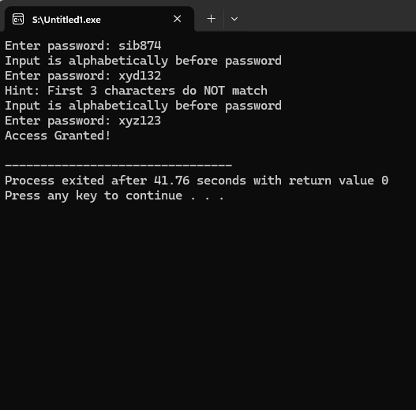

Q3:
Code:
#include <stdio.h>
#include <string.h>

int main() {
char email[50], copy[50], format[100];

printf("Enter email: ");
scanf("%s", email);

strcpy(copy, email);

char *ptr = strchr(copy, '@');

if (ptr == NULL) {
printf("Invalid email!\n");
return 0;
}

printf("Domain: %s\n", ptr + 1);

if (strstr(ptr + 1, ".") == NULL) {
printf("Invalid domain!\n");
return 0;
}

strcpy(format, "Email: ");
strcat(format, email);

printf("%s\n", format);

return 0;
}
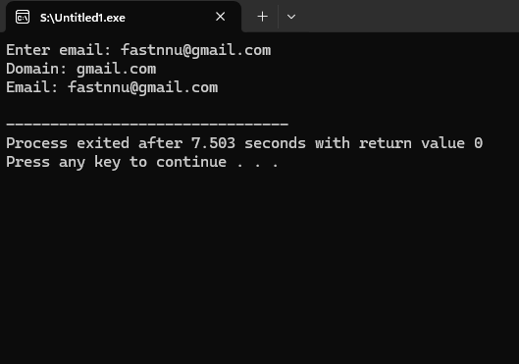
Q4:
Code:
#include <string.h>

int main() {
char names[5][30];
char search[30];
int x, found = 0;

for (x = 0; x < 5; x++) {
printf("Enter name %d: ", x + 1);
fgets(names[x], 30, stdin);
names[x][strcspn(names[x], "\n")] = '\0';
}

printf("\nStudent List:\n");
for (x = 0; x < 5; x++)
printf("%s\n", names[x]);

printf("\nEnter name to search: ");
fgets(search, 30, stdin);
search[strcspn(search, "\n")] = '\0';

for (x = 0; x < 5; x++) {
if (strcmp(names[x], search) == 0) {
printf("Found at position %d\n", x);
found = 1;
break;
}
}

if (!found)
printf("Student not found\n");
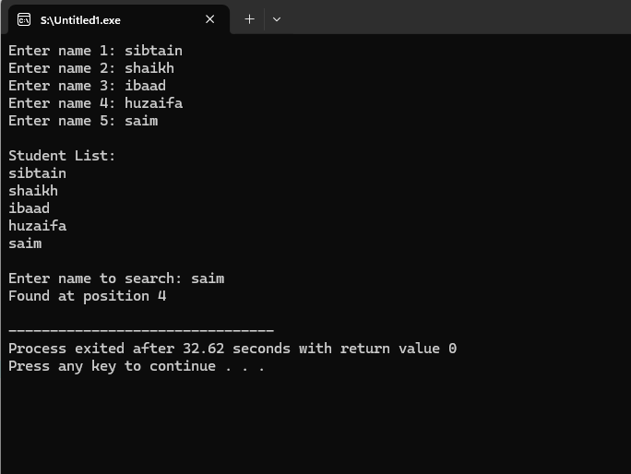

Q5:
Code:
#include <stdio.h>
#include <string.h>

int main() {
char words[6][20];
int seen[6] = {0};
int i, j;

for (i = 0; i < 6; i++) {
printf("Enter word %d: ", i + 1);
scanf("%s", words[i]);
}

for (i = 0; i < 6; i++) {
if (seen[i] == 1)
continue;

int count = 1;

for (j = i + 1; j < 6; j++) {
if (strcmp(words[i], words[j]) == 0) {
count++;
seen[j] = 1;
}
}

printf("\nWord: %s | Count: %d\n", words[i], count);

printf("Characters: ");
for (j = 0; words[i][j] != '\0'; j++) {
printf("%c ", words[i][j]);
}
printf("\n");
}

return 0
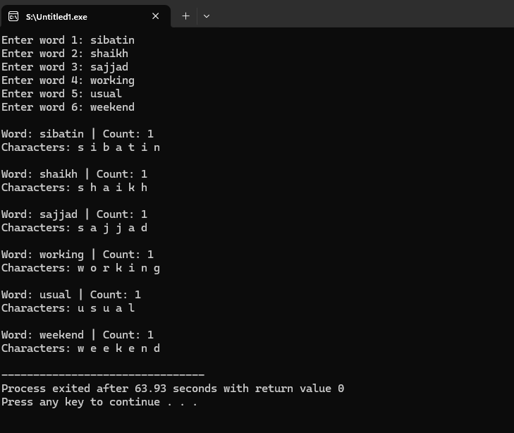

Q6:
Code:

int main() {
FILE *fptr;
char name[50];
int grade, x;

fptr = fopen("grades.txt", "w");
if (fptr == NULL) {
printf("File error!\n");
return 0;
}

for (x = 0; x < 3; x++) {
printf("Enter name and grade: ");
scanf("%s %d", name, &grade);
fprintf(fptr, "%s %d\n", name, grade);
}

fclose(fptr);

fptr = fopen("grades.txt", "r");

printf("\nRecords:\n");
while (fscanf(fptr, "%s %d", name, &grade) != EOF) {
printf("%s %d\n", name, grade);
}

fclose(fptr);
return 0;
}
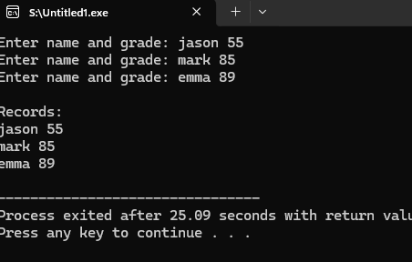

Q7:
Code:

#include <stdio.h>

int main() {
FILE *fptr;
char product[30];
int qty;

fptr = fopen("inventory.txt", "a");
if (fptr == NULL) {
printf("File error!\n");
return 0;
}

printf("Enter product and quantity: ");
scanf("%s %d", product, &qty);

fprintf(fptr, "%s %d\n", product, qty);
fclose(fptr);

fptr = fopen("inventory.txt", "r");

printf("\nInventory:\n");
while (fscanf(fptr, "%s %d", product, &qty) != EOF) {
printf("%s %d\n", product, qty);
}

fclose(fptr);
return 0;
}

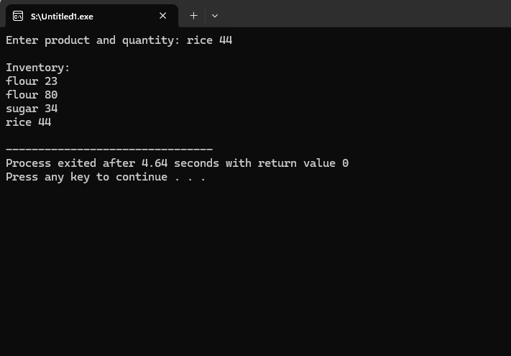

FOR 4 OUTPUTS, RUMTIME =4;
Q8:
CODE:
int main() {
FILE *fptr;
int i, score, sum = 0, val;

fptr = fopen("survey.txt", "w");

for (i = 0; i < 5; i++) {
printf("Enter score: ");
scanf("%d", &score);
fprintf(fptr, "%d\n", score);
}

fclose(fptr);

fptr = fopen("survey.txt", "r");

while (fscanf(fptr, "%d", &val) != EOF) {
sum += val;
}

float avg = sum / 5.0;

printf("Sum = %d\n", sum);
printf("Average = %.2f\n", avg);

fclose(fptr);
return 0
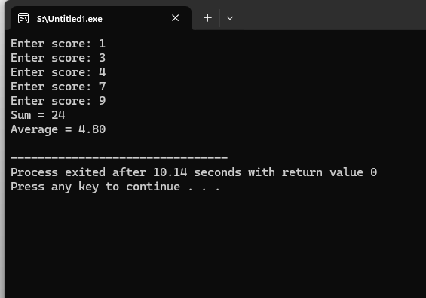

Q9;
CODE:
#include <stdio.h>

int main() {
FILE *fptr;

fptr = fopen("config.txt", "r");

if (fptr == NULL) {
printf("File not found. Creating default config...\n");

fptr = fopen("config.txt", "w");

fprintf(fptr, "max_users=50\n");
fprintf(fptr, "timeout=30\n");
fprintf(fptr, "mode=default\n");

fclose(fptr);
} else {
printf("Config file exists.\n");
fclose(fptr);
}

return 0;
}
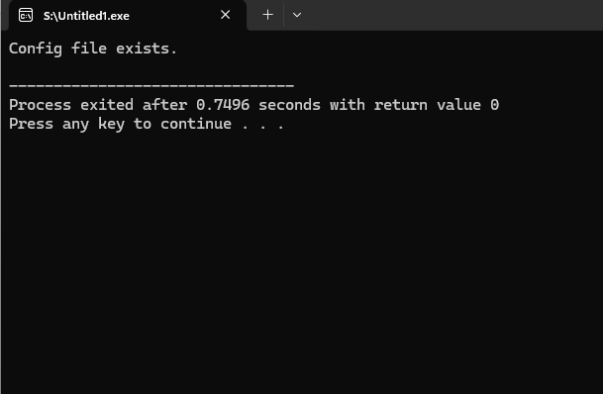

Q10:
CODE:
#include <stdio.h>

int main() {
FILE *fptr;
char name[30];
int s1, s2, s3;
float avg;

printf("Enter name: ");
scanf("%s", name);

printf("Enter 3 scores: ");
scanf("%d %d %d", &s1, &s2, &s3);

avg = (s1 + s2 + s3) / 3.0;

fptr = fopen("report.txt", "w+");

fprintf(fptr, "Name: %s\n", name);
fprintf(fptr, "Scores: %d %d %d\n", s1, s2, s3);
fprintf(fptr, "Average: %.2f\n", avg);

if (avg >= 50)
fprintf(fptr, "Status: Pass\n");
else
fprintf(fptr, "Status: Fail\n");

rewind(fptr);

char line[100];
printf("\nReport Card:\n");

while (fgets(line, sizeof(line), fptr)) {
printf("%s", line);
}

fclose(fptr);
return 0;
}